**XJTLU Angel Fund**

**Investment Application and Business Plan**

**Applicant**：**__________Dequn Teng________________________**

**Application Date**：**__________2020 Sep 4____________________**

**Project Title**： SyncStudy

**Investment Method**： Equity Investment

**Company Name**：SyncStudy Educational Technology Company

**Company Address**： XJTLU

**Project Code (For XJTLU)** ：**______________________**

1. **Project Details**

|  |  |  |  |  |  |  |  |  |
| --- | --- | --- | --- | --- | --- | --- | --- | --- |
| Project Title | SyncStudy | | | | | | | |
| Project Applicant | Dequn Teng | | Tel No. | | 18663118927 | Phone No. | | 13863157299 |
| Project Contact Person | Dequn Teng | | Phone No. | | 18663118927 | Email Address | | [Dequn.teng17@student.xjtlu.edu.cn](mailto:Dequn.teng17@student.xjtlu.edu.cn) |
| Project Start Date | July 20 2020 | | No. Of Start-up Enterprise Members (if applicable) | | 5 | No. Of Project Group Members | | 5 |
| Project Total Investment Amount (RMB) | 300000 | | Invested Amount (RMB) | | 150000 | Applied Investment Amount ( RMB) | | 150000 |
| Applied Investment Years (no more than 3 years) | 3 | | Proposed transferred shares (applicable to equity investment) | | 5% | | | |
| If you apply for the fund in the name of company, please provide the information of the company and patents. | | | | | | | | |
| Company Introduction | Company Title | | SyncStudy Educational Technology Company | | | Name Of Corporate Representative | | ?? |
| Registration Date | | Registration Address | Registration Type | | Registration Capital | | Shareholders Composition |
|  | |  |  | | 300000 | | 6:3:1 |
| Company Technological Field | Education, Internet, Math | | Patents | √Accepted No. of Projects _11__  🞎 Authorized No. of Projects ___  Technical disclosure:2 | | | | |
| Patent Name | The utility model relates to a method and a device for confirming commodity trading information  The invention relates to an audit method, device, audit equipment and storage medium based on block chain  A method for processing donated information, a device, an electronic device and a storage medium  The utility model relates to a method, device, electronic equipment and storage medium for a donated project  Revolving hand grenade  Armored vehicles  An instrument for applying medicine to large area of skin  Blockchain-based methods, devices, devices and storage media for fund projects  Capability level analysis methods, devices, electronic equipment and storage media  The utility model relates to an electric arm training apparatus  The utility model relates to a SPA device for efficient spraying | | | | | | | |
| Project Shareholders Interests | | | | | | | | |
| Project Shareholders | | Shareholders Name | Percentage Of Shares | Investment Amount (RMB) | | Investment Method | Phone No. | |
| Dequn Teng | 63% | 100000 | | Deposit | 18663118927 | |
| Group | 31.635% | 50000 | | Deposit |  | |
| XJTLU | 5% | 150000 | | Deposit |  | |
|  |  |  | |  |  | |
| Project Introduction and Business Scope | | Chinese overseas studies are a highly potential market for the launch of SyncStudy, especially within XJTLU, where nearly 5000 students are going abroad along with its rapid development. However, there are three pain points of the market, which  are low utilization rate of university resources, high price paid for external agency for graduate studies, and superfluous or even fake ”make-up” throughout the graduate school application. This business plan determines to introduce a new  business mechanism, where SyncStudy integrate ability improving resources and make recommendations to students base on the requirements of master degree application, which are key concerns for most students. Throughout this approach,  students are gaining a much more comprehensive understanding of ability improvement approaches, together with a higher confidence in graduate school application, leaving less necessity for purchasing agency services externally, with the relief of family. Throughout this service approach, SyncStudy will polish and refine our service experience based on the large volume of data, and making consultant services for students who want to go abroad in top 10-100 universities in China, possibly with the help of Learning Mall and increase the popularity of XJTLU worldwide. | | | | | | |
| Project Advantages and Core Competitiveness | | Advantages  XJTLU students potentially have 3000 students in master degree application overseas, if we can serve students freely  or at the one tenth of the market price for different requirements from the user  • We have comprehensive understanding the utilization of resources within the campus  • The information within the overseas studying market is quickly out of date, and we can keep model refined using the  updated data, which is especially designed for the target school and major  • Low price for students service, one tenth of the market price  • High qualified educational resources provided and supported by XJTLU learning mall  Core Competitiveness   * Resources Gathering   In depth understand of resources provided across the campus   * Model Building   All first prize of mathematical modeling competition   * Consultant   All awarded with the top class consultant courses and top class admission | | | | | | |
| Feasibility Plan | | Industrial Analysis  China has been the largest source country for the international students over the past ten years. In the nearly 30 years tide of study abroad, agencies helping students who intend to study in the foreign countries were once spreading prosperously from 1990s. However, this kind of institutions are malleable to the change of international policies and government policies since these conditions have directly influence to the college and visa applications. Study shows the growth of study abroad industry experienced a decrease per annum between 2012 to 2015. In 2020, the study abroad tendency slows down sharply and many institutions bankrupt including EduBoston which is one the biggest study agencies in America, and countless smaller enterprises related to this business. With the decoupling of Sino US relations, the industry of study abroad is shrinking, and predictably this fact will last at least for ten years. Though the situation is difficult for study abroad business according to the ‘White paper on the current situation and trend of Chinese students' application for studying abroad in 2020’ China will still remain its place in the contribution of the international students. Therefore, the transfer and alternatives of study abroad industries are highly demanded and possibly necessary for each institution.  This is a quite challenging period for most study abroad agencies in China, however, there are still various opportunities. According to the discussion of The 14th Five Year Plan the trend in China including digital infrastructure, internal circulation of scientific research and business, and the industrial upgrading will release large dividends for enterprise and indicate the direction of study abroad business. Some Sino foreign cooperative universities especially Xi’an Jiaotong-Liverpool University (XJTLU) makes impressive performance in this field, and this mainly reflects to its resources including exploration of frontier domains, integration of school and enterprise, learning supermarkets, etc.  Business Pattern  With the background of XJTLU, Sync Study is a new type study abroad consultation platform focusing to help students maximize the utilization of resources in XJTLU. The aim of resource integration ensures each student of XJTLU fully use the chances offered by the universities and become more competitive in the future trend of China and world with a considerably floor price. Sync Study also develop models and applications specifically to students of XJTLU. This service to some extent can replace an experienced school application guide and even perform better than traditional empiricism consultant. This will also directly reduce the cost for students making study abroad consultant, since it breaks the benefit pattern of conventional institutions who profit from the information inequality between students and agencies. Therefore, the service provided by Sync Study is proper to the expectation of students, social development, and the market.  Technologies Realization  To improve the customer service experience technologies related to applications and algorithms are developed including patent of ..  Competition Analysis  According to the industrial analysis, the competition in this field is grueling. For the competition between XDF, ApplySquare, GGU, Compass, Alumnin MAX, etc. Some of these institutions such as XDF, GGU, ApplySquare have existed for many years. So, the disadvantages of Sync Study compared to these agencies are less credibility, hardship attracting off campus resources and less business experience. However, the resources of Sync Study are from the integration of XJTLU, which is more useful and closer to students of XJTLU. So, with the development of Sync Study, students will realize the usefulness and convenience of our platform, then the status of Sync Study will be improved by years. Except for those big agencies, there are some small institutions also built by seniors of XJTLU for example Alumnin MAX, Aguero-edu, and Johnny Education. Compared with these enterprises, Sync Study has its own advantages including more direct relationship with the school resources, and closer to school development projects and teachers. Most importantly, Sync Study provide both professional school selection and calibration positioning service, and the price of service is much lower than the 10% price of any competing institution.  Team Development  The Sync Study management and R&D teams are formed from young adults who are at the point of application and some experienced seniors who provide mentor service for our clients. From the list of management team, all the group members are strong and competitive in special field, and their experience is enough to prove the reliability and professional ability. Besides, the executive policies are improved with the business spreading. Sync Study also encourage students of XJTLU to participate in the team and provide training for intended students. The team development is with the growth of managers, staffs and interns with a core slogan and purpose. | | | | | | |
| Project Intellectual Property Management | | This project consists of two direct related patents, and the group totally include 11 patents varied in domains.  The first two directly related patents are “Capability level analysis methods, devices, electronic equipment and storage media”, and “The invention relates to an audit method, device, audit equipment and storage medium based on block chain”  Both the two patents have been included in the attachments for your reference. The first one has passed the initial evaluation, while the second one has entered the substantial evaluation period. | | | | | | |
| Project Plan for three years’ development and Operation Objectives in different phases | | Stage 0  Our Team will focus on the market of XJTLU and get well-prepared for the business and R&D. We are going to investigate the school market to discover inspiration of functional demands and potential business in convenience of future expansion. We will also fill our working team with qualified and passionate new friends to spread our scale. Besides, the App will be put into use and the model for giving students advice will be build and adjusted. The customer service experience will be ensured and improved.  Stage 1  During stage 1, Sync Study will be able to abundant the mentor groups with sufficient previous clients, thus the service system could be consummated and elavated. Our group members will increase and the business is gonging to expand. The intended customers are to be students of sino-foreign coorperative universities and the credibility and satus could be established.  Stage 2  In this stage, Sync Study will grow up to be compete in bigger market. Our intentional clients will add students planning to study abroad in the 10th to 100th univerisities of China. When we are able to provide service for more than 3000 clients per year, even if we are in a local market other than XJTLU whose share is not high, because XJTLU is the largest Sino-foreign cooperative university in China and is expanding at a rapid rate, not to mention the overall British, the attractiveness of learning is gradually increasing for most lower-level students. Through appropriate market research, we are able to have  enough experience in the tertiary market competitive. | | | | | | |
| Analysis on market forecast and financial benefits | | **Market Forecast**  Figure 1: Market Forecast  Starting with the October, after the approval of the university, we will firstly introduce the membership fee, for providing the resources explanation service, it is because we can help students in fully utilize resources provided within the campus, and it is beneficial for students to join the member, while polishing a higher educational level within campus.  During November, since we are fully preparing for the XIPU innovation competition, and we add up the marketing strategies for a higher reputation, which clearly need the help from the university.  After the December, it is shown that the main benefits come from the resource drain, advertisements, and mentor service. However, these services may not be that beneficial for the market income, and this period is a steady growth period, when the team is building and doing the data analysis, modeling refinement in preparing the market hit at the May.  In May, there will be a big hit for development, and it is because the students are facing the pressure from the examination. Additionally, this trend will be continuing until the end of July when the exam result will be released.  In the coming August, the students involvements are generally smaller, where students are enjoying their summer vacation and the university resources are generally at a low utilization rate, which is within our expectation.  In the coming September, the member will be much higher since new students are coming and SyncStudy has gained a high reputation within the campus.  Figure 2: Financial Benefits  引流服务 advertising drainage service  Mentor对接服务 mentor service  会员费 membership  自媒体/广告 self-media management  自提供服务 integrated service  In terms of the financial benefits, nearly 40 percent of income come from the membership fee, while the second largest one comes from the memtor recommendation. The following resources redirect, advertisement, and self raised services will count for the remaining 30 percent of income.  **Financial Benefits**  The financial benefits of Sync Study are mainly from five dimensions including advertising drainage service, self-media management, membership, mentor, and integrated service. The fundamentally beneficial purpose depends on the mass users paying for membership services all over the years, and meanwhile the other business services increase continuously or at least, remain the same market rate. However, during the initial period of a start-up business, the primary income of Sync Study could be contributed by internet flow such as the advertising for sponsor enterprises and the management of self-media management. While during this period, with a high-quality online platform Sync Study is also ready for a positively massive growth of the membership service. This is an essential accumulation of customers though it is at the end of year 2020, and then the membership service will go on a healthy and seasonal development if the group membership is stably increasing in the early stage.  Other business including mentor and integrated services are not expected to be large or extremely profitable from the beginning. However, with the congestion of customers’ data, experience and credibility, Sync Study is hoped to expand the services in mentor and integrated plans. Therefore, these two services are predicted to be the future brandy products with more benefits than any other business except membership. | | | | | | |
| Project Marketing and Sales Plan | | **Product**  Our product is based on the university resources, providing resources gathering, model building, and application consultant services for students.  **Promotion**  **Online**  • self-media  • Article  **–** Admission profile analysis  **–** Senior interview  • Video  **–** Medium video  ∗ Study abroad experience sharing  ∗ Turn the current public account article into a video  **–** Short video (demystifying body)  ∗ Demystify! UCL admissions student portrait  ∗ Characteristics of 80% of students admitted  **Offline**  • Posters  • Lectures  **Place**  **Online**  • Video  **–** Chinese video (mainly science popularization and education sharing)  ∗ Bilibili (including live broadcast): Target college students (completed)  ∗ IQiyi: Target parents of college students  ∗ Youtube: Target international students  ∗ Youku (Dayu.com): Target parents of college students  ∗ Watermelon Video: Target parents of college students  **–** Short video (shocked, shocked! University of London admissions portraits exposed!)  ∗ Douyin: Target college students and parents  ∗ Kuaishou (specific investigations, whether to adopt this method, and how popular is the middle class?)  • Article  **–** Sina Weibo (target students and parents)  **–** Sina Blog (traditional way)  **–** WeChat official account (target: students and parents)  **–** WeChat channel (target: students and parents)  **–** Twitter (target: international students)  **–** Zhihu (Target: Student)  **–** Today’s headlines (target: parents)  **–** Baijiahao (target: parents)  **–** Short book (target: students)  **–** CSDN (Target: Computer Science Students)  **–** LinkedIn (target: alumni and potential cooperation)  **Offline**  • Outside restaurant  • On campus poster  • Outside our store  **Customer Relationship Management**  In order to encourage more users to engage in SyncStudy and reward loyalty users, we have developed an incentive program. The incentive program provides five different categories of badges based on the percentage of a daily missions such as generating one post on the ”board”, following three most competitive applicant in the corresponding domain. In terms of different achievements achieved by different users, they may get different rewards such as little gifts. | | | | | | |
| Project Risk Analysis and proposed solutions | | • Policies  – The changeable international condition and policies of foreign countries makes it hard for some student to finish  the course, complete the language tests and even get the scores. This will increase the difficulties of admission.  • Competition  – The scarcity of popularity and status push us hard to compete with the famous institutions.  • Technologies  – The R&D process of the mini program App has not been ready.  • Managements  – Most members of the initial group are studying abroad very soon.  – The instability of administration team could forestall the development of the corporation.  • Finance  – The gap of price between XJTLUers and non-XJTLUers is big enough to lose clients of other schools.  – The cost for personnel is huge amount.  – We are exile for the experience of financing. | | | | | | |
| Work Place | | Need place or not 🞎 No √Yes, need square meter  Length for Usage：_______3_______  The purpose of usage：______Providing Resources for students and model building_____________ | | | | | | |
| Proposed Investment Withdrawal Plan | | We proposed strategies for these risks in case of emergency. While reducing the cost is necessary, we still could consult a senior in this field to help. The price reported to other school’s students should be controlled to no more than double of the XJTLUers’. Besides, the consultant fee of a mentor could be paid by the student separately, even though in the free program. It is also important to contact with school’s teachers and department to integrate free information and resources. Moreover, the business expansion to other school should be executive cautiously since the different policies and situation could affect  the competitiveness of Sync Study. | | | | | | |

1. **Project Investment and Return Analysis**

**1. Source of Fund**

**Unit: 10,000RMB**

|  |  |  |  |  |  |
| --- | --- | --- | --- | --- | --- |
| Content | Estimation Expense in Each Year | | | | Explanation of Funding Source |
| Total Amount | 2020 | 2021 | 2022 |
| Project total investment | 100 | 30 | 40 | 30 |  |
| Planned Contributed Investment | 50 | 15 | 20 | 15 | Self Raised |
| Angel Fund Investment | 50 | 15 | 20 | 15 | XJTLU |

**2. Project Expenditure Budget and Angel Fund Investment Ratio**

**Unit: 10,000RMB**

|  |  |  |  |  |  |  |  |  |  |
| --- | --- | --- | --- | --- | --- | --- | --- | --- | --- |
| Item | Budget Amount | | | | | | | | Notes |
| Total | | 2020 | | 2021 | | 2022 | |
| Total amount | Applied fund amount | Total amount | Applied fund amount | Total amount | Applied fund amount | Total amount | Applied fund amount |  |
| Facility / Device / Equipment | 3 | 3 | 1 | 1 | 1 | 1 | 1 | 1 | Decorations |
| Operation | 3.6 | 3.6 | 1.2 | 1.2 | 1.2 | 1.2 | 1.2 | 1.2 | Consultation |
| R&D | 3.6 | 3.6 | 1.2 | 1.2 | 1.2 | 1.2 | 1.2 | 1.2 | App update |
| Others (please specify here:_Patent______) | 3 | 3 | 1.2 | 1.2 | 1.2 | 1.2 | 0.6 | 0.6 | Patent |
| Total | 13.2 | 13.2 | 4.6 | 4.6 | 4.6 | 4.6 | 4.6 | 4.6 |  |

**3. Project ROI Analysis**

Please provide the revenue forecast analysis for the project and ROI analysis.

|  |  |  |  |  |  |  |  |  |  |  |  |  |  |  |  |  |  |  |  |  |  |  |  |  |  |  |  |  |
| --- | --- | --- | --- | --- | --- | --- | --- | --- | --- | --- | --- | --- | --- | --- | --- | --- | --- | --- | --- | --- | --- | --- | --- | --- | --- | --- | --- | --- |
| |  |  |  |  |  |  |  |  |  |  |  |  |  |  | | --- | --- | --- | --- | --- | --- | --- | --- | --- | --- | --- | --- | --- | --- | | 模块 | 十月 | 十一月 | 十二月 | 一月 | 二月 | 三月 | 四月 | 五月 | 六月 | 七月 | 八月 | 九月 | 合计 | | 合计 | 7990 | 21950 | 12980 | 12990 | 14990 | 19990 | 16990 | 45860 | 47850 | 59800 | 26975 | 87700 | 261390 |   Figure 3: Quarter ROI Analysis  Since we apply for the deposit of 150000 RMB, and the quarterly investment is roughly 37500 yuan, the corresponding budget together with the corresponding revenue come the membership fee, advertisement fee, redirect fee, mentor service, and self-raised service. Based on the figure 3, it turns out in the first two quarters, the corresponding ROIs are relatively low, however, in the third and fourth quarter the ROI has been much dramatically higher compared with the first two quarters, which are between 3 to 4, serving to be a relatively a higher ROI for investor. |

1. **Project Applicant and Project Team**

**1. Project Applicant**

|  |  |  |  |  |  |
| --- | --- | --- | --- | --- | --- |
| Name | Dequn Teng | Gender | Male | 出生年月  Date of Birth | 1999 Jan 27 |
| Nationality | China | ID No. | √ Identification 371002199901270533  🞎 Passport | | |
| Occupation | Student | Highest Education Degree | Bachelor | Graduation Time | 2021 June |
| Current residential address | Tashan East Road No.148C301 Weihai, Shandong | | | Post Code | 264200 |
| Phone No. | 18663118927 | | | Email Address | Dequn.Teng17@student.xjtlu.edu.cn |
| Resume | | | | | |
| Start and End Month | Institution or Company | | | Major of degree or responsibilities of occupation | |
| September 2019 - Present | University of Liverpool (UoL), the United Kingdom | | | Computer Science and Electrical Engineering (BEng) | |
| June 2019 - August 2019 | Stanford University, the United States of America | | | Summer Session of artificial intelligence and algorithms | |
| September 2017 - June 2021 | Xi'an Jiaotong-Liverpool University (XJTLU), China | | | Computer Science and Technology (BEng) | |
| Working experience and achievements | | | | | |
| Smart Follow Me drone by Autopilot  A drone which can follow a person to y, and response based on voice information, capable of wireless charging and image transmission technique based on Pixhawk, Beagleboard, Raspberry, and Alexa Drone Skill. As team manager and voice control module, I polished programming, hardware assembling, leadership, and team communication skills.  2020 Mathematical Contest in Modeling in Matlab, Excel  To find the best policy for the soccer team's performance, I implemented Markov decision process to apply Q-learning to do reinforcement for finding an optimal policy. Applied depth first search to find strongly connected components in the player passing network. Applied neural network for predicting team-level performance indicator. Applied max flow and min cut algorithm to analysis the most essential defense area in competition.  Multi-Agent Pacman in Python  I characterize the state-based two-player zero-sum games, and based on min-max, and optimal policy against an adversary. Additionally, using alpha-beta pruning, the efficiency of min-max is improved by eliminating unnecessary branches. Gained further understanding in Game Theory, and multi-agent system.  Car Tracking in Python  Based on Bayesian Network and Hidden Markov Model, I designed car agents that use a sensor to locate other cars and drive. Based on Probabilistic inference and maximum likelihood algorithm, the car drive safely. Developed understanding in Bayesian Network.  Course Scheduling in Python  Formed course scheduling as factor graphs, and applied backtracking search, dynamic ordering, lookahead (enforcing Arc consistency) to filter optimal assignment(s). Gained further understanding in constraints satisfaction problems.  Movie Ticket Selling System in C++  Designed and implemented a movie ticket selling system in C++ and SQLite. The administrator can add, delete, modify, surf and calculate the profile of each movie. Customer can surf, buy tickets and select seats by themselves. As the team manager, I polished my programming and communication skills.  Robomaster Infantry Robot in C  Designed and assembled an infantry robot based on Mecanum Wheel in the Robomaster competition using Solidworks and Kernel. I developed management, communication, research, and hardware implementation skills. | | | | | |

**2. Project Team Members**

|  |  |  |  |
| --- | --- | --- | --- |
| No. | Name | Responsibilities in the Team | Phone No. |
| 1 | Dequn Teng | Technical | 18663118927 |
| 2 | Mingran Jia | Manager | 18896503916 |
| 3 | Shaolu Zhang | Accounting | 15391512795 |
| 4 | Mingrui Wang | Modeling | 18115688182 |

**3. Please provide the resumes of the team members as per the template of the applicant.**

1. Other documents as attachments to theapplication
2. If the applicant applies for the fun in the name of company, please provide copy of business license of the start-up enterprise, copy of tax registration certificate, identity certificate of the corporate representative, he auditing report of the start-up enterprise for the previous year before the application and the financial statement of recent one month;
3. If you have patent rewards, please provide relevant copy of the certificate;



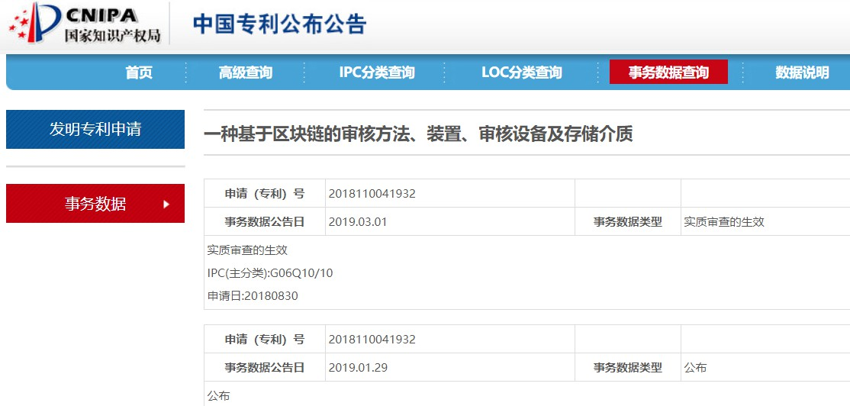

1. The identity certificate of the applicant and the responsible person;

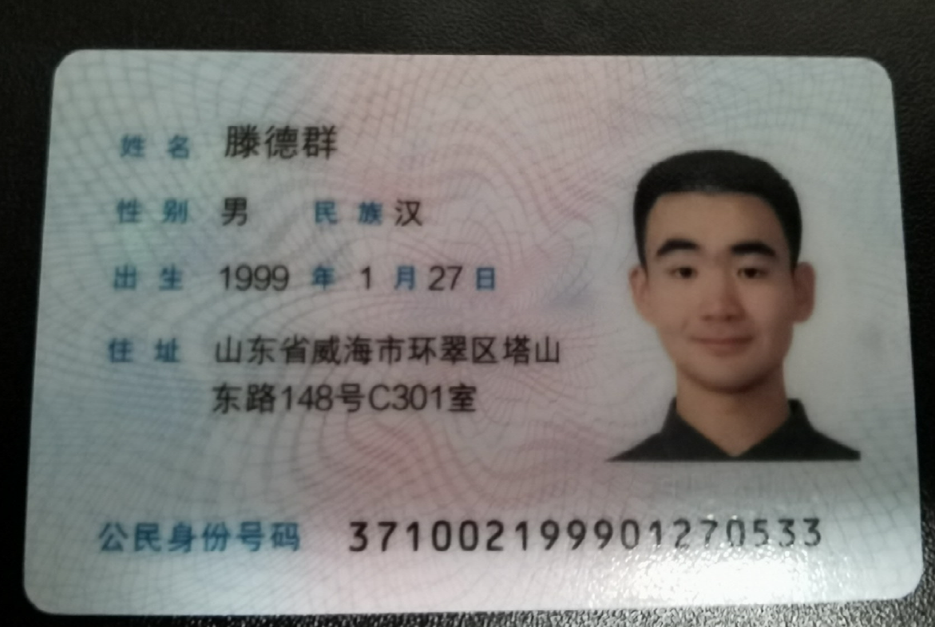

1. Certificate of enrollment or graduation certificate of the applicant;

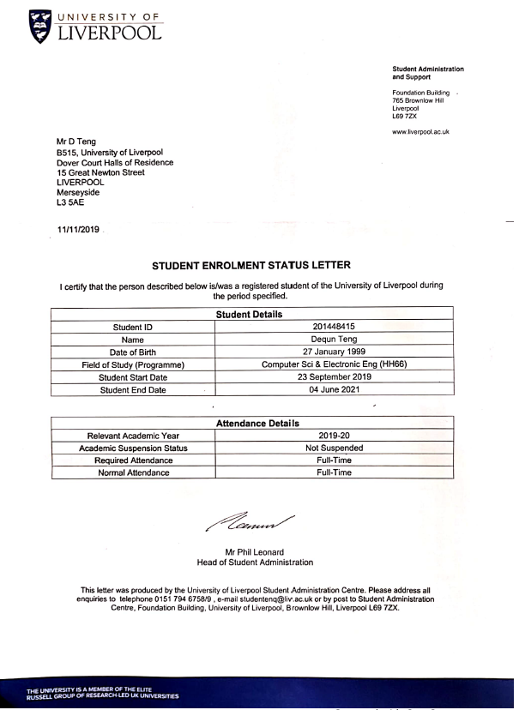

1. The certificate of bank verification account and investment capital (the fund will be transferred to the account if the project is approved to be funded)

Bank account: 6214 8551 2793 6405

Total investment capital: 15w

1. Reference：

<https://www.tandfonline.com/doi/abs/10.2753/CED1061-193233058>

<https://insights.navitas.com/market-trends-signal-shifts-in-chinese-student-demand/>

<http://china-cer.com.cn/shisiwuguihua/page_2.html>

Mini Program QR code



1. The Commitment of Applicant

|  |
| --- |
| I acknowledge that the content provided in the form is accurate and reliable, and the intellectual property involved in the project is clear. I shall should any legal responsibilities if there are any consequences arising from inaccurate information or intellectual property disputation. The relevant departments of Xi’an Jiaotong-Liverpool University shall inquire me regarding the application and other materials where necessary.  Applicant Name: Dequn Teng Year/Month/Date  2020 9 4  Responsible Person Name: Dequn Teng Year/Month/Date  2020 9 4  Note: Please seal with company stamp if apply in the name of a company. |